PocketLab OP484 Analog Amplifier Stage
Initial Gain, Safe-Idle, Waveform Fidelity, and Clipping Test Results
Project | PocketLab Function Generator | Test date | July 13, 2026
Test time | Approximately 5:00–6:00 PM PDT | Author | Mark Anderson

Purpose
The purpose of this test was to build and characterize the first OP484 analog-conditioning stage using the known-good AD9833 sine and triangle outputs. The stage AC-couples the DDS signal, replaces its approximately 0.34 V DC bias with a buffered half-supply reference, and applies noninverting voltage gain. Testing established basic gain accuracy, waveform fidelity, stopped-output behavior, and the maximum useful swing available from a USB-powered 4.71–4.75 V supply.

Circuit configuration
Item | Connection / value
Amplifier | OP484, channel A; single-supply operation
Supply | ESP32 USB-derived 5 V pin; measured 4.71–4.75 V
Reference | Equal-resistor divider buffered by OP484 channel B; approximately 2.4 V
Signal coupling | AD9833 OUT through 1 µF capacitor; 100 kΩ bias resistor to buffered VREF
Gain topology | Noninverting: Av = 1 + Rf/Rg
Measured Rg | 10.19 kΩ, from channel A inverting input to buffered VREF
Oscilloscope load | Digilent Analog Discovery / WaveForms, high-impedance input
Test frequency | Approximately 1 kHz

Results summary
Test | Rf | Calculated gain | Input | Output | Measured gain | Result
Initial sine | 10 kΩ | 2.00 | ≈0.607 Vpp | 1.2146 Vpp | ≈2.00 | Clean
Sine | 46.3 kΩ | 5.544 | 0.61292 Vpp | 3.3214 Vpp | 5.419 | Clean
Triangle | 46.3 kΩ | 5.544 | 0.60842 Vpp | 3.3268 Vpp | 5.468 | Clean
High-gain sine | 67.9 kΩ | 7.664 | 0.61022 Vpp | 4.5793 Vpp | 7.504 | Rail limit
Overdrive sine | 89.9 kΩ | 9.822 | 0.61112 Vpp | 4.7111 Vpp | 7.709* | Clipped

* The clipped-stage Vpp ratio is not the linear gain; the output is constrained by the supply rails.

Safe-idle observation
When firmware stopped the AD9833 output, the 1 kHz waveform disappeared and the amplifier output settled to the buffered reference. WaveForms measured an average of 2.4107 V with 26.188 mV peak-to-peak residual activity at the displayed scale. This confirms that the AC-coupling network prevents the AD9833 stopped-state DC level from being amplified. It does not yet create a ground-referenced 0 V external safe-off state; the present internal idle level is approximately VREF.
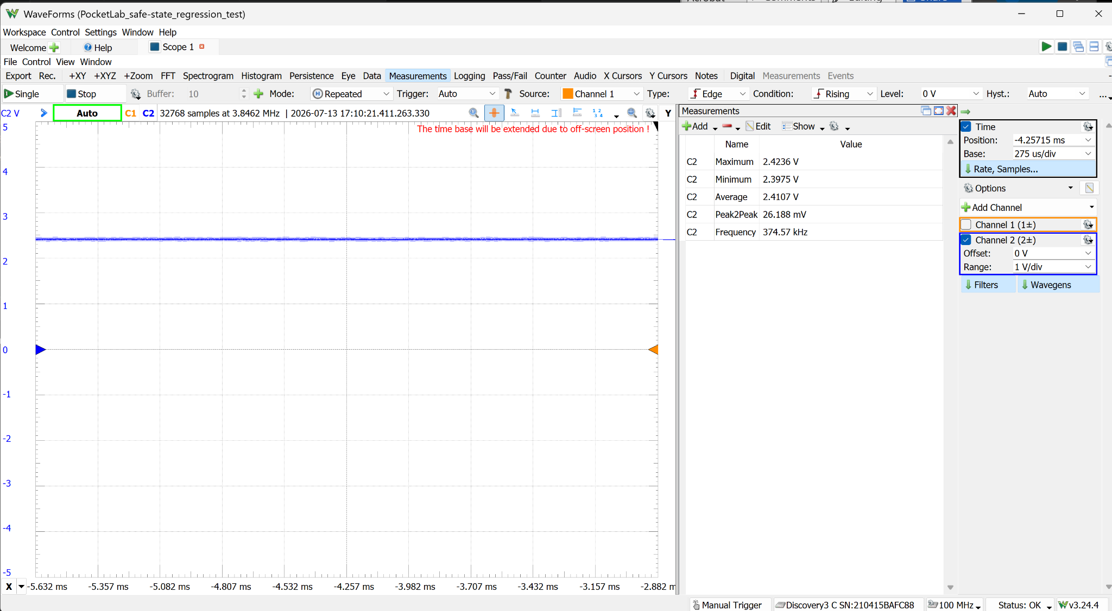
Figure 1. OP484 output after stopping the AD9833: approximately 2.41 V internal idle level with no 1 kHz waveform.

Waveform fidelity at gain ≈ 5.54
Using measured resistor values Rf = 46.3 kΩ and Rg = 10.19 kΩ, the calculated closed-loop gain was 5.544. The measured sine and triangle gains were 5.419 and 5.468, respectively. Both waveforms remained stable and unclipped. The triangle retained straight slopes and sharp turning points, indicating that the amplifier reproduced the AD9833 waveform without visible slew-rate limitation at 1 kHz.
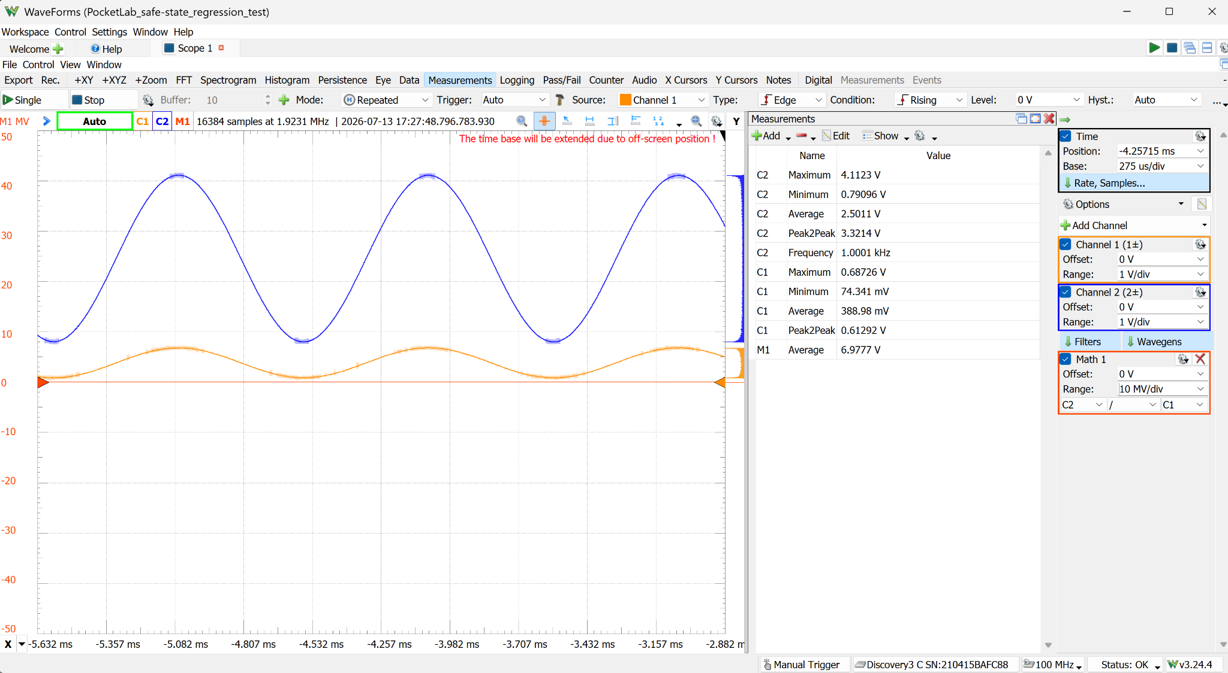
Figure 2. Simultaneous sine measurement: C1 is the raw AD9833 output; C2 is the OP484 output at measured gain 5.419.
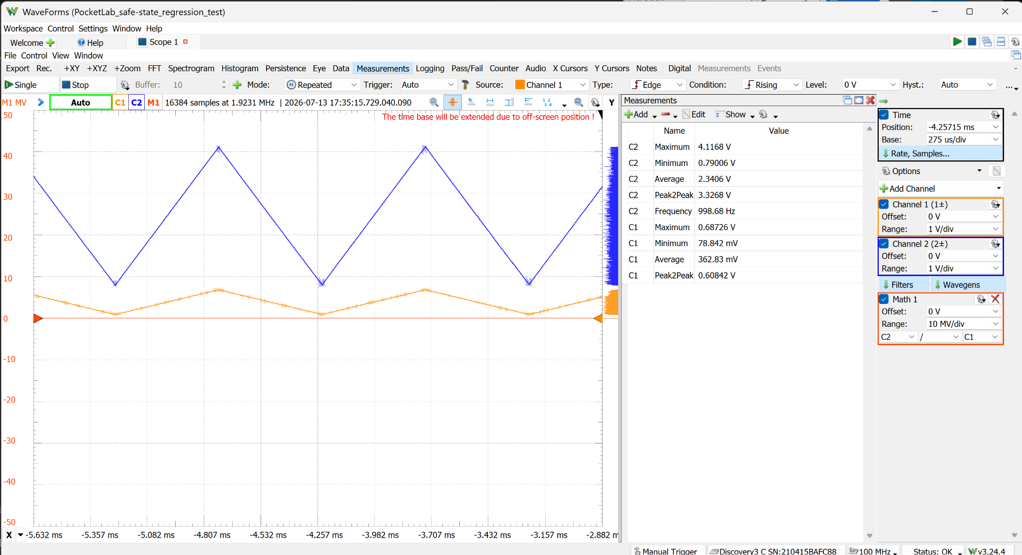
Figure 3. Triangle-wave fidelity at measured gain 5.468. No visible clipping, ringing, or instability was observed.

Output-swing and clipping boundary
With Rf increased to 67.9 kΩ, the calculated gain was 7.664 and the measured output reached 4.5793 Vpp. The positive peak reached approximately the measured supply rail, indicating the onset of saturation even though obvious flat-topping was not visible. This establishes approximately 4.58 Vpp as the observed practical upper boundary into the oscilloscope’s high-impedance input, not as a guaranteed low-distortion output specification.
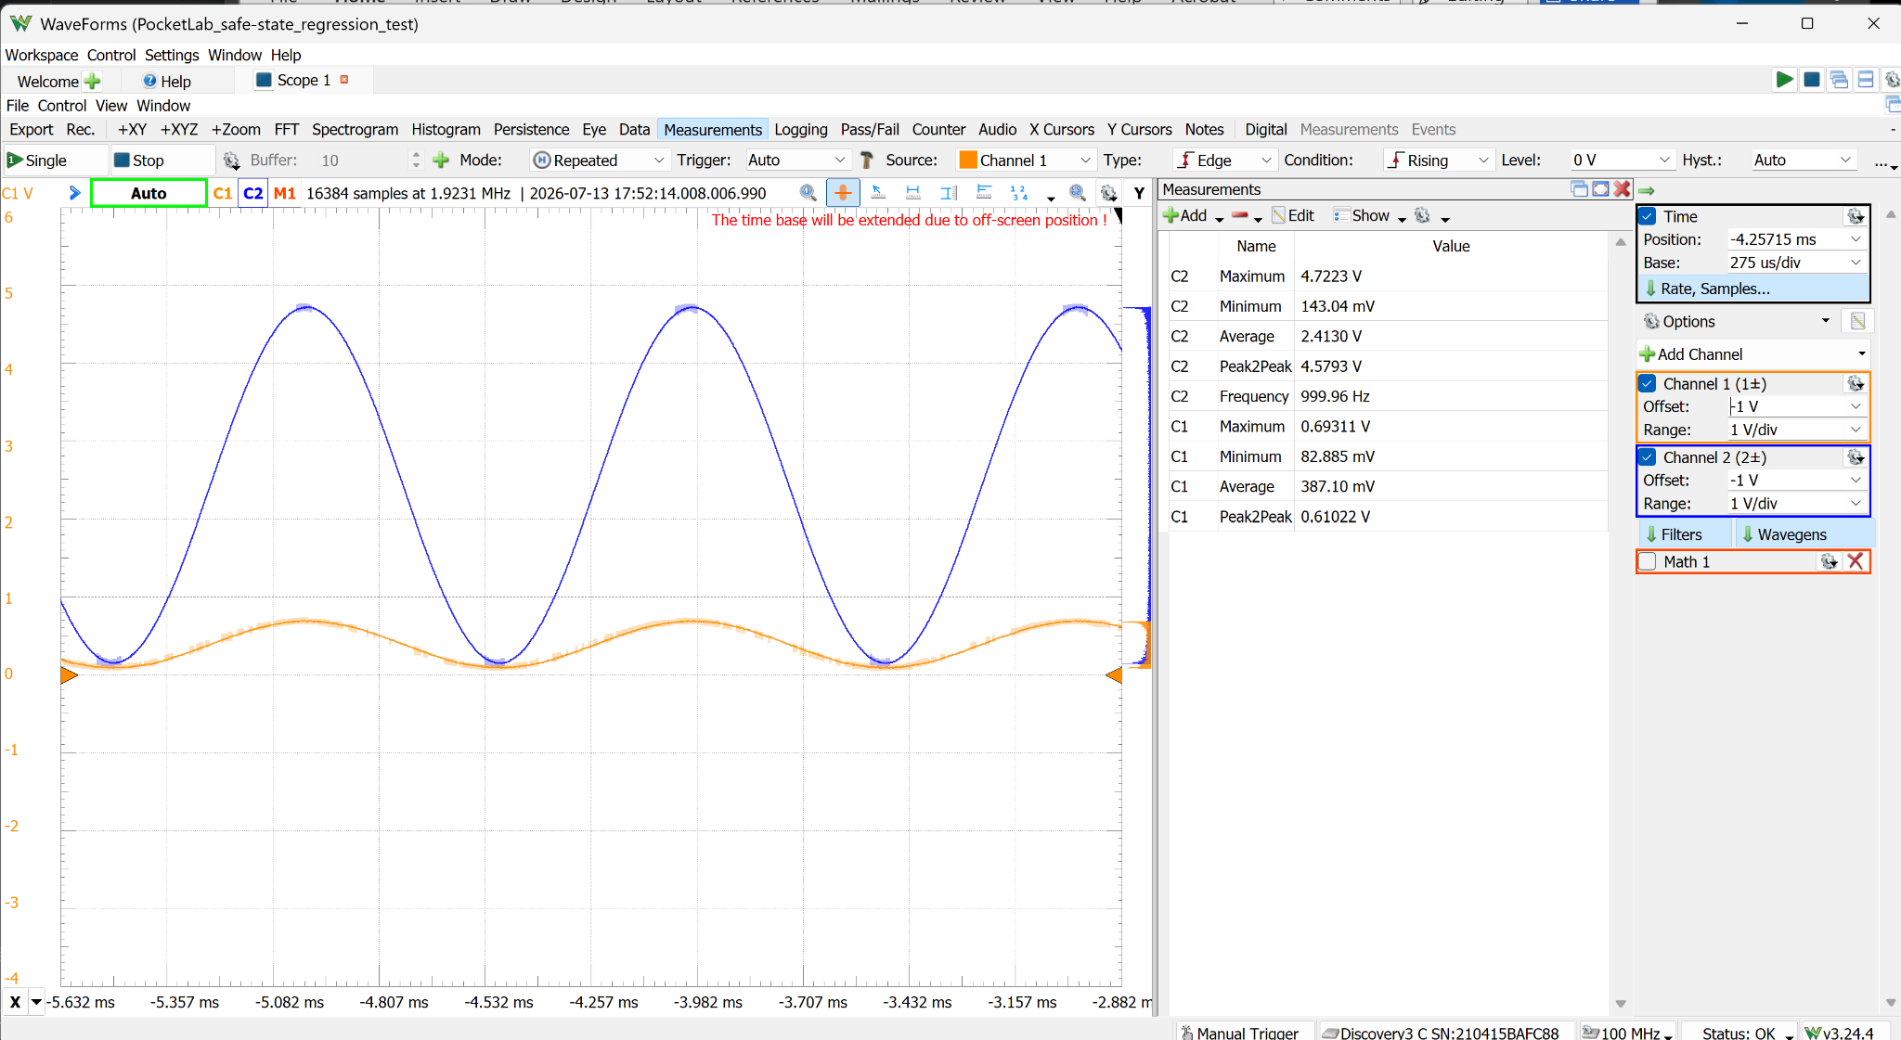
Figure 4. Gain 7.664 configuration: 4.5793 Vpp output, with the positive peak effectively reaching the 4.71 V supply rail.
Adding a second 22 kΩ series resistor increased Rf to approximately 89.9 kΩ and requested an ideal output near 6.00 Vpp. Because the circuit was powered from approximately 4.71 V, the output saturated at both rails and measured 4.7111 Vpp. The extended horizontal regions at the upper and lower peaks are definitive hard clipping.
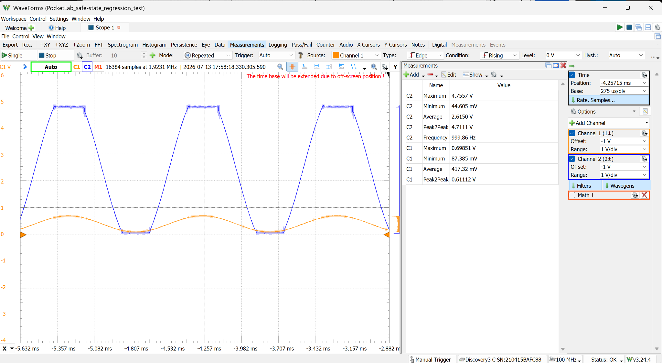
Figure 5. Gain 9.822 overdrive test: unmistakable two-sided clipping at the supply rails.

Conclusions and design implications
- The OP484 fixed-resistor stage correctly removed the AD9833 DC bias through AC coupling, rebiased the waveform around approximately 2.4 V, and provided the intended noninverting gain.
- Sine and triangle signals were amplified cleanly at 1 kHz through a calculated gain of 5.544, producing approximately 3.32 Vpp.
- A calculated gain of 7.664 produced approximately 4.58 Vpp and reached the practical rail limit on the 4.71 V USB-derived supply.
- A calculated gain of 9.822 demanded approximately 6.00 Vpp and produced obvious hard clipping, confirming the available output-swing boundary.
- A final fixed maximum gain near 7.0–7.2 is recommended, corresponding to Rf near 60–62 kΩ with Rg near 10 kΩ. This should target approximately 4.3–4.4 Vpp while retaining margin for USB variation, component tolerance, and loading.
- The X9C103S can subsequently be placed ahead of the fixed-gain stage as an attenuator, allowing digitally controlled amplitude from approximately zero to the selected clean maximum.
- The internal stopped state remains approximately VREF rather than 0 V. A later output-coupling, switching, or level-shifting stage is still required for a ground-referenced external safe-off voltage.

Recommended next tests
Priority | Test | Purpose
1 | Choose Rf near 60–62 kΩ and repeat sine/triangle tests | Establish a repeatable clean maximum near 4.3–4.4 Vpp
2 | Frequency sweep at 1, 10, 50, 100, and 200 kHz | Measure bandwidth, gain roll-off, and waveform distortion
3 | FFT/THD comparison at moderate and near-limit amplitudes | Quantify distortion before visible clipping
4 | Add X9C103S input attenuator | Verify digital amplitude control and zero-amplitude behavior
5 | Develop final output buffer/protection and safe-off stage | Provide load drive, protection, and external 0 V idle

